
Year 11
PSYCHOLOGY ATAR 2022

TASK 8 – Personality
Project – Case Study Presentation
(Weighting: 10%)

Time allowed:
2 weeks to prepare presentation
8-10 minutes to present to the class
15 minute validation (5 minutes planning and 10 minutes writing)

Name: ____________________________________
SECTION | MARKS AVAILABLE | YOUR MARK
PRESENTATION | 40
VALIDATION | 10
TOTAL MARKS | 50
 |  | %

Select two of the following types of personality theories on which you would like to base your case study.

- Psychoanalytic theory (Freud)
- Trait theories (Cattell or Eysenck)
- Humanist theories (Rogers)

For each of the two types of theories you have chosen:
- work with one adult who is willing to discuss personal experiences with you. (This should be a relative or a close friend. Ensure that you gain their informed consent. Reassure them that their responses will remain confidential).
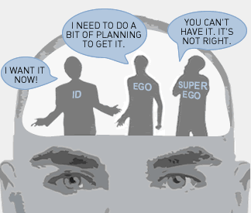
- develop a simple interview,
- develop 2 activities to aid you in your exploration of their personality (one activity for each theory).
.
Freud / Psychoanalytic Theory
- Ask the person to describe their childhood, values and influences
- Suggested ways of exploring your participants’ personalities that might be tied in with Freud’s theory include:
  - 9 TAT pictures are attached. Ask your participants to respond to one of the chosen pictures and tell you a story about it. If they are having a problem ask questions like, “Who are these people? What are they doing? Is there a problem here? What will happen next?”Do NOT try to analyse their response. Just record the information given.
  - Discuss topics relating to the parts of the psyche, such as “Do you believe that you are highly self-critical?” (superego), “Are you frequently impulsive?” (id) “Would you say that you are a highly rational person?” (ego). Use any similar questions that would help.
  - Try the alternate questions.
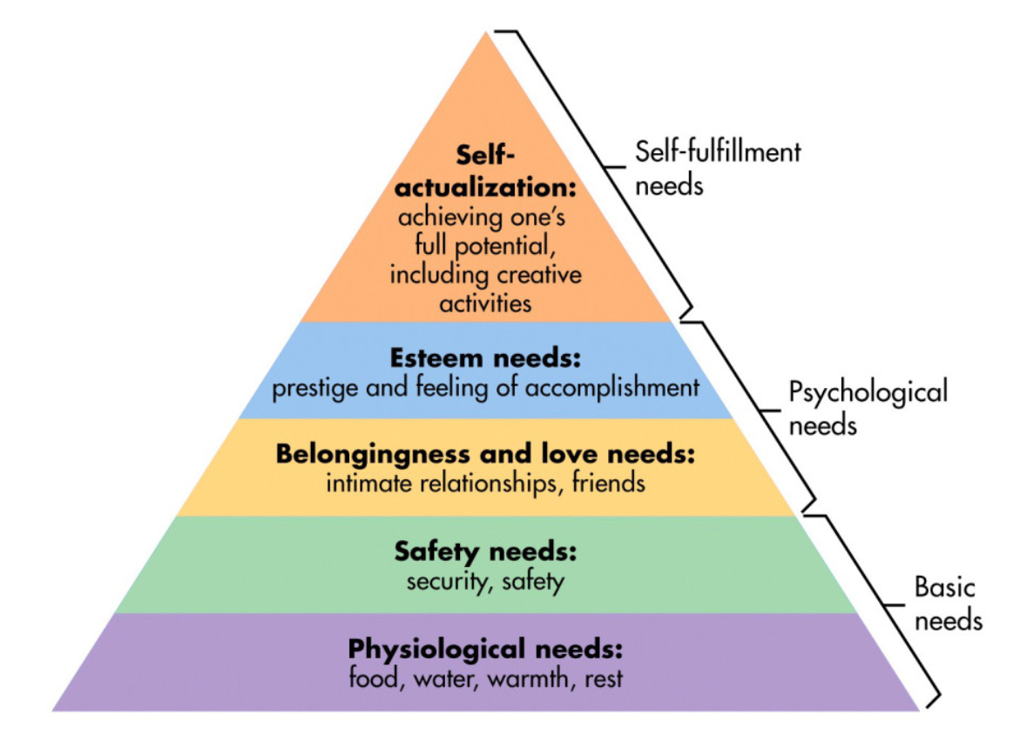
Humanism (Rogers/Maslow)
- Ask your participant to describe their childhood, values and influences
- Suggested ways of exploring your participants’ personalities that might be tied in with Rogers’ theory include:
- Use the words we used in class and ask them to create two lists, a ‘real self’ and an ‘ideal self’. Talk to them about the similarities and differences.
(We have done this in class).
- Show them Maslow’s hierarchy of needs and ask them to explain where they are at the moment and how they progressed through the levels in their own lives. Record the results.
(We have done this in class).
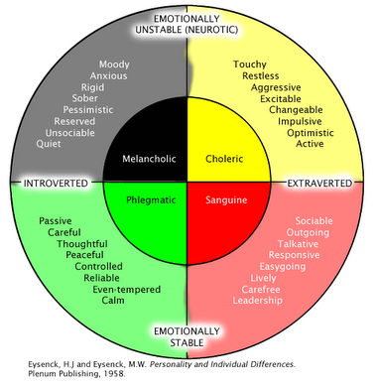
Trait Theorists
- Ask your participant to describe their childhood, values and influences
- Suggested ways of exploring your participants’ personalities that might be tied in with trait theories include:
      - Use Eysenck’s dimensions of personality diagram, asking your participant to highlight or circle the 10 characteristics most like them.
      - Use the Cattell handout provided showing his 16 traits and ask them to complete the online test. Discuss the results with them. Do they agree with the findings? Record the results

Presenting your case study

Your presentation should include:

- A definition and broad overview of Personality.

- A brief account of the main aspects of the two theorists you have chosen.

- A brief account of the activities you used in exploring your participant’s personality.

- A report on the participant, which includes:
- a general account of their childhood, values and influences.
- the possible influence of heredity and environmental factors in the participant’s life.
- an account of your findings on each activity used to explore your participant’s personality.
- how could you have improved your methodology
- were there any findings that particularly interested you or your participant?

**Note – Shaded sections on the marking key may be submitted as a separate document to protect confidentiality for the participant if requested

Marking key – Report on Personality

Description | Marks
Definition and overview of Personality |  | /5
- Provides a clear and acceptable definition of personality  - Does not provide a clear definition of personality | 1  0
- Provides a broad overview of personality, including historical perspectives, describes psychodynamic, traits and humanistic aspects  - Provides a broad overview of personality and describes psychodynamic, traits and humanistic  - Briefly describes the three aspects  - Describes one or two aspects | 4  3  2  1
2 chosen aspects |  | /6
- Clearly identifies and describes the work and history of the theorist chosen. Connects the theorist with the theory selected and describes the technique(s) employed by that theorist  - Clearly identifies and describes the work of the theorist chosen. Briefly discusses the technique(s) employed by that theorist  - Describes the technique(s) of the theorist | 3 x 2  2 x 2  1 x 2
Activities chosen |  | /8
- Clearly describes the two activities chosen, explaining how they connect with the theory chosen. Also indicates how they will be presented to the participant. Including examples of questions / visual aids  - Briefly describes the two activities chosen, explaining how they connect with the theory chosen. Also indicates how they will be presented to the participant. Including examples of questions / visual aids  - Briefly describes the two activities chosen, explaining how they connect with the theory chosen.  - Describes the two activities chosen without explanations | 4 x 2  3 x 2  2 x 2  1 x 2
Report |  | /14
- Introduces the participant, explaining how they were selected and the relationship | 1-2
- Clear description of your findings on each activity utilised with references to the participant’s personality  - Description of findings on each activity utilised without clear reference as to how it was used to explore the participant’s personality  - Brief mention of the activities without referring to findings and how the activities were utilised  - No evidence of findings although the activities may be described | 3 x 2  2 x 2  1 x 2  0
- Gives a thorough report on the childhood, values and influences, quoting examples from the participant  - Gives a brief report on the childhood, values and influences, quoting examples from the participant  - Gives a brief report on the childhood, values and influences of the participant  - Gives a vague report on the childhood, values and influences of the participant | 4  3  2  1
- Discusses heredity and environmental factors in the participant’s life, giving examples as supplied by the participant  - Discusses possible heredity and environmental factors in the participant’s life | 2  1
Conclusion |  | /4
- Has clearly indicated how methodology could have been improved  - Has briefly indicated how methodology could have been improved | 2  1
- Has made a number of analytical connections between participant and the theory chosen  - Has made a few meaningful analytical connections between participant and the theory chosen | 2  1
Expression |  | /3
- Clear, logical structure, fluent speech and appropriate text and graphics. 8-10 minutes in length.  - One of the following not to standard: Content is sequenced illogically, speech not fluent or text not suitable for viewing, or not 8-10 minutes in length  - Two of the following not to standard: Content is sequenced illogically, speech not fluent or text not suitable for viewing, or not 8-10 minutes in length | 3  2  1
Total | /40

Unseen question (10 marks)
Compare the similarities and differences between your two chosen theories.

Response
- Clearly describes the idea behind each theory and how personality arises according to each | 1-2
- Clearly describes one difference between the methods for measuring personality | 1-2
- Clearly describes one difference in use for determining personality according to each theory | 1-2
- Discusses two similarities between the two theories. | 1-4
Subtotal | 10

